**Lab 10,11**



Spring 2021

Computer Programming

Submitted by: **Maaz Habib**

Registration No.: **20PWCSE1952**

Section: **C**

“On my honour, as student of University of Engineering and Technology, I have neither given nor received unauthorized assistance on this academic work.”

Submitted to:

**Engr Abdullah Hamid**

Department of Computer Systems Engineering

University of Engineering and Technology, Peshawar

**Task 01**

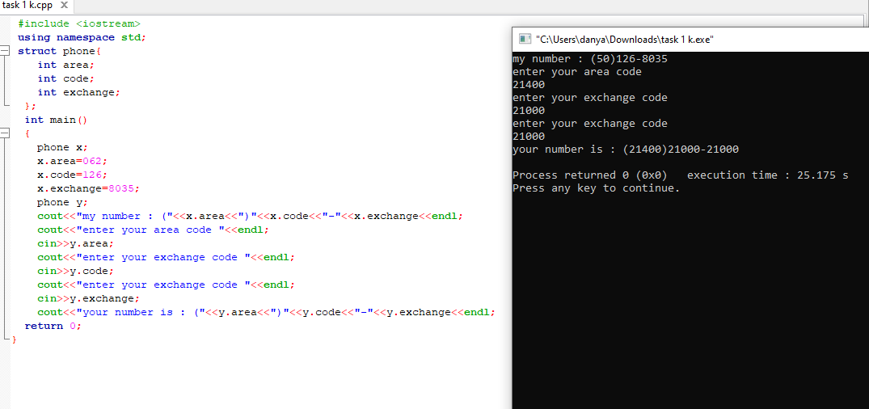

**Task 2**

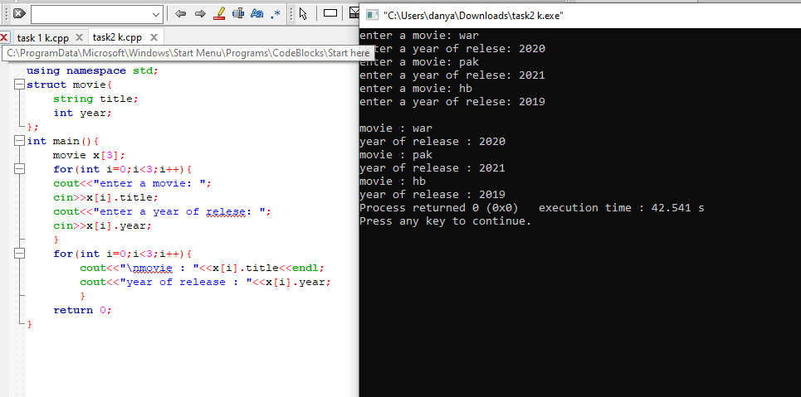

**Task 03**

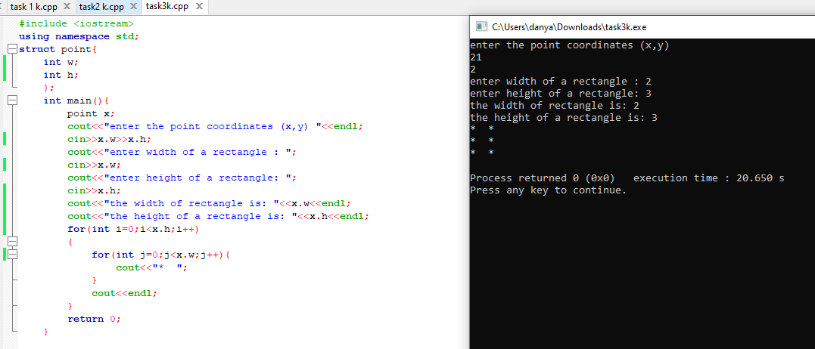

**Task 04:**

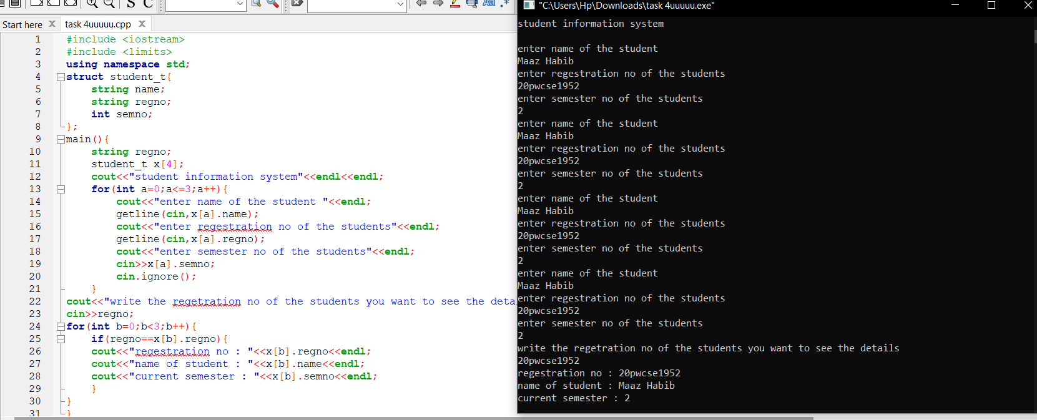

**Task 05**

